CEA Web Developer assignment

**Note: Choose any ONE from the given two assignment.**

Assignment 1

**Requirements and Problem statement**

1. Create a React App which show stocks data using chart library (d3, highcharts, uplot and etc). Feel free to use any charting library.
2. You can use [Aplha Vantage Docs](https://www.alphavantage.co/documentation/) as an API or [Polygon Io](https://cea3cn-my.sharepoint.com/personal/gyadav_cea3_com/Documents/or%20https:/polygon.io/docs/getting-started) API. You will need to register and get an API key.
3. If you feel generating API key is cumbersome, you can make a local csv or json file and use it as an API to get the stocks data. Refer below diagram

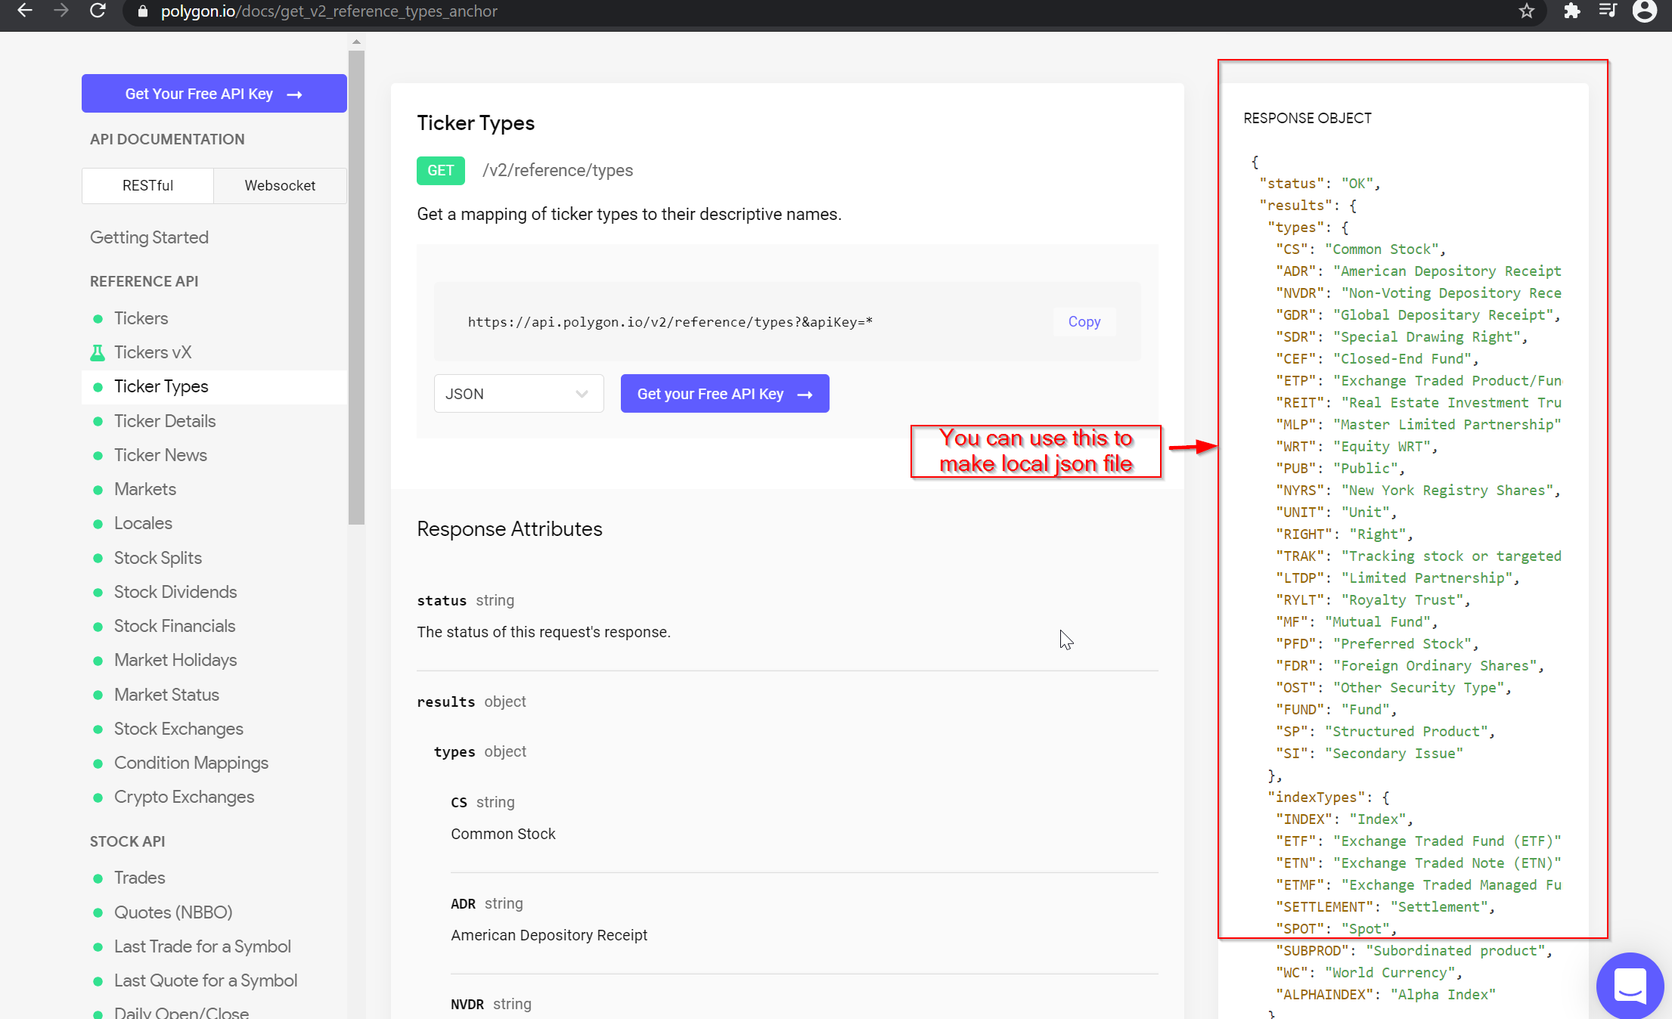

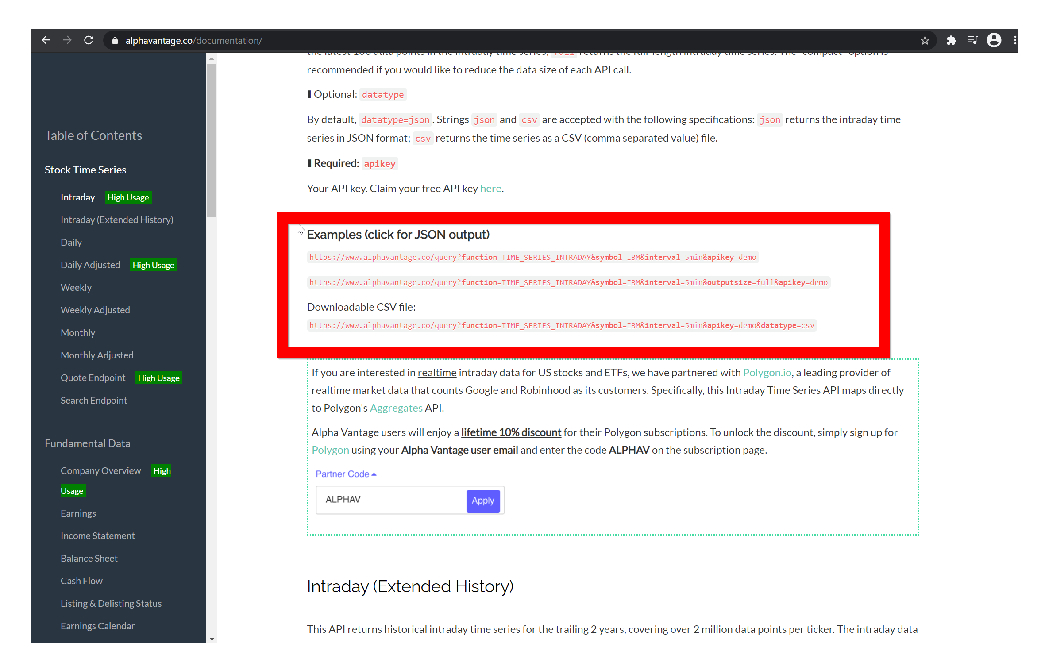

1. See how stock charts looks (different charts library showing different type of stock charts)

* [Highcharts Stock demo](https://www.highcharts.com/demo/stock)
* [uPlot demo](https://leeoniya.github.io/uPlot/demos/index.html)

1. Have a look at a website showing stock charts and data [Stock Chart website](https://www.nseindia.com/)

**Functionalities**

1. Create a home page which shows a drop down menu for different stocks symbol(stock name). On selecting a symbol it should show the chart for the relevant symbol (stock name).

[What is symbol ? Read here on docs](https://www.alphavantage.co/documentation/).

1. Create a compare page which compares two or more symbols (stock name). It should show latest or todays values for low, open and high only in tabular format.

For example AAPL vs Google.

3. Use Redux or Context API or Hooks to store state. Use a UI LIbrary (Preferrably Material-UI or Semantic React or any CSS Framework)

Assignment 2

**Requirements , Functionalities and Problem statement**

1. You need to develop a CRUD (Create, Read, Update and Delete) for posts.
2. Use the JSON Placeholder API to fetch, update, and create posts
3. A search bar to search posts
4. A functionality to like and dislike posts
5. Different pages for each CRU Operation
6. Different Pages for Liked and Disliked Posts
7. Use Redux or Context API to store Liked and Disliked Posts and list of posts
8. Use a UI LIbrary (Preferrably Material-UI or Semantic React)

**Submission- Submit a GitHub code link and deployed project link as well**